National Healthcare Providers Registry
What is Milestone M4?
National Healthcare Providers Registry (NHPR) is a comprehensive repository of registered Healthcare Professional and Health Facility.
Healthcare professionals with different system of medicines (Modern medicine, Dentistry, Ayurveda, Unani, Siddha, Sowa-Rigpa, Homeopathy) and Nurses practitioners delivering healthcare services across India.
Health Facilities like hospitals, clinics, diagnostic laboratories and imaging centers, pharmacies, bloodbanks, etc.
Integration of NHPR functionality in the healthcare application/software is milestone M4. Integrating with M4 functionalities will enable registration of health professionals and health facilities natively.
After an entity successfully completed integration of ABDM milestones, M1, M2, and M3, integration for M4 can be initiated. To proceed with this integration following roles should be assigned to the client-id:
- HPID role
- HFR role
Steps for NHPR native integration?
Integration Workflow (Sequence for APIs Implementation)
- Implementation of Test Cases ( https://sandbox.abdm.gov.in/sandbox/v3/new-documentation?doc=TestCases )
- Functional Testing (NHPR Team) ( write to abdm.texp1@nha.gov.in ; facility.abdm@nha.gov.in for an internal demonstration )
- Share video recording of the implemented workflow with NHA
- Security Certificate submission ( Security audit report along with VAPT report )
- Assignment of required roles (HFR/HPID) by NHA team
Website: https://hspsbx.abdm.gov.in/home
Please go to the menu item, Resource Center -> API Documentation for documentation and presentation with registration steps on NHPR portal.
Benefits of NHPR
National Healthcare Providers Registry
What is Milestone M4?
National Healthcare Providers Registry (NHPR) is a comprehensive repository of registered Healthcare Professional and Health Facility.
Healthcare professionals with different system of medicines (Modern medicine, Dentistry, Ayurveda, Unani, Siddha, Sowa-Rigpa, Homeopathy) and Nurses practitioners delivering healthcare services across India.
Health Facilities like hospitals, clinics, diagnostic laboratories and imaging centers, pharmacies, bloodbanks, etc.
Integration of NHPR functionality in the healthcare application/software is milestone M4. Integrating with M4 functionalities will enable registration of health professionals and health facilities natively.
After an entity successfully completed integration of ABDM milestones, M1, M2, and M3, integration for M4 can be initiated. To proceed with this integration following roles should be assigned to the client-id:
- HPID role
- HFR role
Steps for NHPR native integration?
Integration Workflow (Sequence for APIs Implementation)
- Implementation of Test Cases ( https://sandbox.abdm.gov.in/sandbox/v3/new-documentation?doc=TestCases )
- Functional Testing (NHPR Team) ( write to abdm.texp1@nha.gov.in ; facility.abdm@nha.gov.in for an internal demonstration )
- Share video recording of the implemented workflow with NHA
- Security Certificate submission ( Security audit report along with VAPT report )
- Assignment of required roles (HFR/HPID) by NHA team
Website: https://hspsbx.abdm.gov.in/home
Please go to the menu item, Resource Center -> API Documentation for documentation and presentation with registration steps on NHPR portal.
Benefits of NHPR
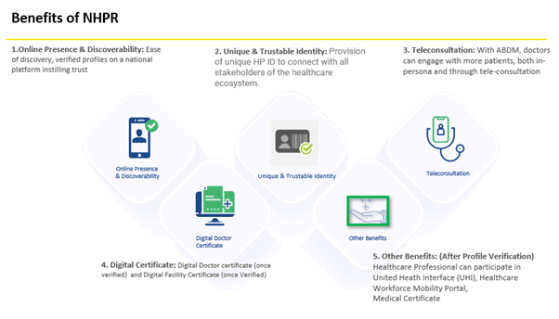

Healthcare Professional Registry
Healthcare Professionals Registry is a comprehensive repository of all verified healthcare professionals involved in delivery of healthcare services across both modern and traditional systems of medicine. Enrolling in the Healthcare Professionals Registry will enable them to get connected to India’s digital health ecosystem.
Currently doctors, nurses and pharmacists can enrol in HPR and going forward other categories of professionals will be added.
Following are the documents. Kindly refer to them-

1. User manual
- User manual of HPR Download

2. Policy
- HPR SOP Policy Download

3. Bulk Upload
- Download Bulk Upload Template
- Download SOP Bulk Upload

4. Swagger link
- V4 Swagger link for HPR - Download

5. NHPR PPT Download

6. Video of Registration Process of HPR

7. API documents
S No. | Name of the document | Sandbox Download link | Production Download link
1. | Register Healthcare Professional (doctors, nurses & pharmacists) API | Download | Download
2. | Fetch Professional Details API | Download | Download
3. | Update healthcare professional API | Download | Download
4. | Update document API | Download | Download
5. | Generate, regenerate & verify Email link API | Download | Download
6. | Generate, resent & verify Mobile OTP API | Download | Download
7. | Search Facility, Find HPRID by Aadhaar number, Verify mobile number same as Aadhaar mobile number API | Download | Download

8. Master Data Fields
- Master Data Fields -Sandbox- Download
- Master Data Fields -Production- Download
- Master API -Sandbox- Download
- Master API -Production- Download

Health Facility Registry
- Health Facility Registry is a comprehensive repository of health facilities of the country across modern and traditional systems of medicine.
- It includes both public and private health facilities including hospitals, clinics, diagnostic laboratories and imaging centers, pharmacies, etc.
- ABDM maintains the national directory of all Healthcare Facilities. A facility needs to first enrol in the health facility registry.
Benefits of Health Facility Registry :
- Unique & Trustable Identity
Facility ID for identification of health facilities across the ABDM ecosystem.
- Online Presence & Discoverability
Listing of health facilities on a national platform and availability in search results.
- Ease of doing business
Digitisation of services reducing the efforts for registration & renewal of various licenses, and empanelment with insurance agencies, TPAs.
- Unified Digital Services
Access to telemedicine, digital health records and HMIS solutions.
Here is the Link to HFIR Document

Documentation
- NHPR PPT Download
- HFR API documentation Download

User Manual
- User Manual Of HFR Download

Bulk upload
- Facility bulk upload Download

HFR SOP
- HFR SOP Download
- V4 Swagger link for HFR - Download

